Active Directory
No secure version – does not work
rem python ldap_integration.py test-connection --server YLDAPTEST-DC01.ldap1test.loc --port 389 --bind-dn "cn=administrator,cn=Users,dc=ldap1test,dc=loc" --password "Linked3-Shorten-Crestless" --base-dn "dc=ldap1test,dc=loc"
secure version ldap
python ldap_integration.py test-connection --server YLDAPTEST-DC01.ldap1test.loc --port 636 --use-ssl --bind-dn "cn=administrator,cn=Users,dc=ldap1test,dc=loc" --password "Linked3-Shorten-Crestless" --base-dn "dc=ldap1test,dc=loc"
How to find the server name
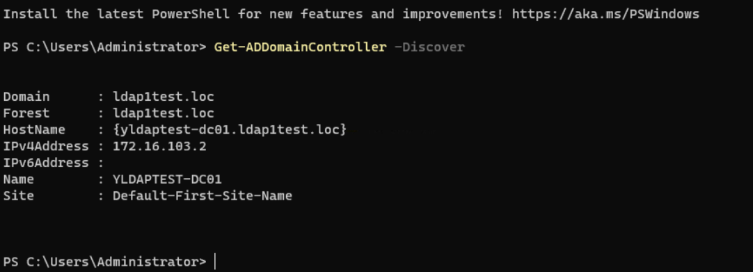

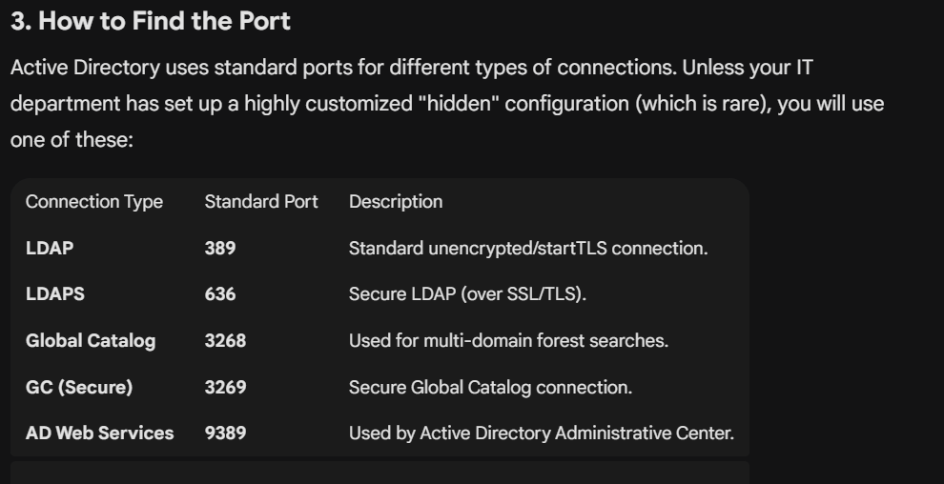
Tip: If you are trying to verify if a specific port is open on your server, you can use the command: tnc <ServerName> -port 389 (PowerShell) or telnet <ServerName> 389 (CMD).
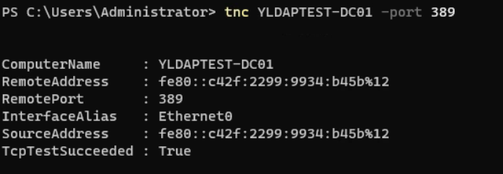
Test also the 636 port for ssl
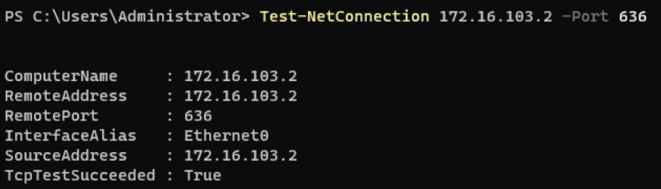

If you are trying to connect a third-party app (like a scanner or a website) to Active Directory, you usually need the Server FQDN (e.g., dc01.yourdomain.com) and Port 389 (or 636 for security).
An FQDN is made up of two parts:
- Hostname: yldaptest-dc01 (The specific name of the server).
- Domain: ldap1test.loc (The Active Directory domain it belongs to).
When you combine them with a dot, you get the FQDN, which is what most applications need to find the server on your network.
yldaptest-dc01.ldap1test.loc
Quick Summary of the Connection Info:
Field | Value from Screenshot
Server FQDN | yldaptest-dc01.ldap1test.loc
IP Address | 172.16.103.2
Domain Name | ldap1test.loc
Quick Summary of Your Connection Info:
Field | Value from Screenshot
Server FQDN | yldaptest-dc01.ldap1test.loc
IP Address | 172.16.103.2
Domain Name | ldap1test.loc
Quick Summary of Your Connection Info:
Field | Value from Screenshot
Server FQDN | yldaptest-dc01.ldap1test.loc
IP Address | 172.16.103.2
Domain Name | ldap1test.loc
Search Base
The Search Base (also known as the Base DN) tells an application exactly where to start looking for users or groups within your Active Directory tree. It uses a specific format called Distinguished Name (DN).
the root Search Base is: dc=ldap1test,dc=loc
How it works
The Search Base breaks your domain name into components (DC stands for "Domain Component"):
- ldap1test becomes dc=ldap1test
- .loc becomes dc=loc
Narrowing it down
If you want the application to look everywhere in the domain, use the root one above. However, if you only want it to look inside a specific folder (called an Organizational Unit or OU), you add that to the front.
Examples:
- To search the whole domain: dc=ldap1test,dc=loc
- To search only a "Users" folder: ou=Users,dc=ldap1test,dc=loc
- To search a "Staff" folder inside "Users": ou=Staff,ou=Users,dc=ldap1test,dc=loc
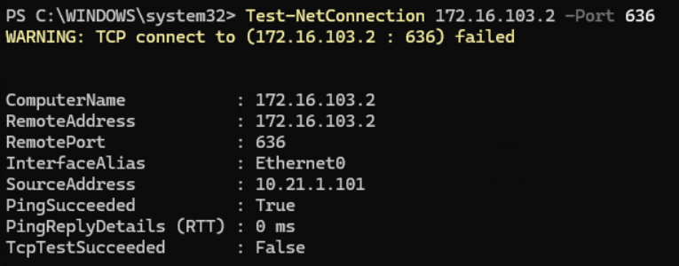

The WinError 10054 error when using the IP address confirms that the network connection is successful, but the Active Directory server is actively rejecting the SSL handshake. This is almost always due to the Python ldap3 library's strict certificate validation failing to trust the Domain Controller's certificate.
Why the Connection is Being Closed
- Self-Signed Certificate: Your Domain Controller is likely using a self-signed certificate that your Python machine does not recognize as valid.
- Security Mismatch: AD sees an incoming request for encryption but terminates it because the client cannot verify the "chain of trust".
- Forced Reset: The "Forcibly closed" message is the server's way of saying it won't talk to a client that doesn't trust its security credentials.

